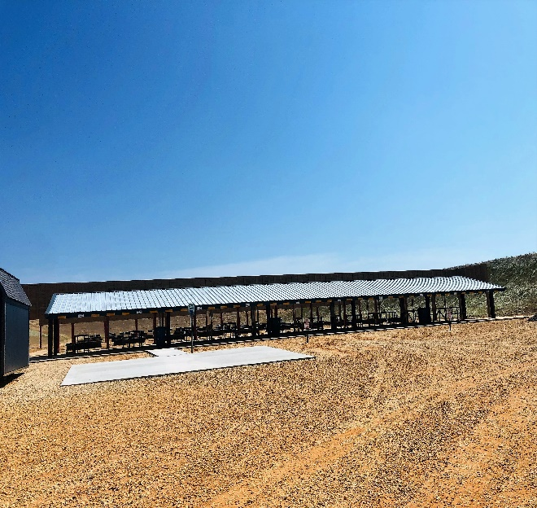

_________HOURS________

Rifle/Pistol Range
Wednesday through Sunday
1:00pm to 5:00pm

Shotgun Range
Wednesday through Sunday
1:00pm to 5:00pm

Law Enforcement Officials…Please call to schedule time

The Warren Shooting Sports Complex offers a 100-yard rifle/pistol range and three (3) combination Trap and Skeet Ranges to sharpen your shooting skills!

Warren Shooting Sports Complex
323 Bradley 38
Warren AR 71671
(870) 820-1428
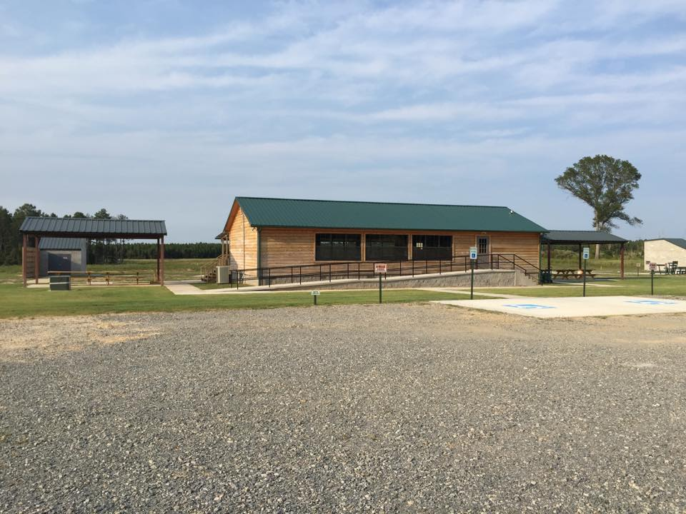

Warren Shooting Sports Complex

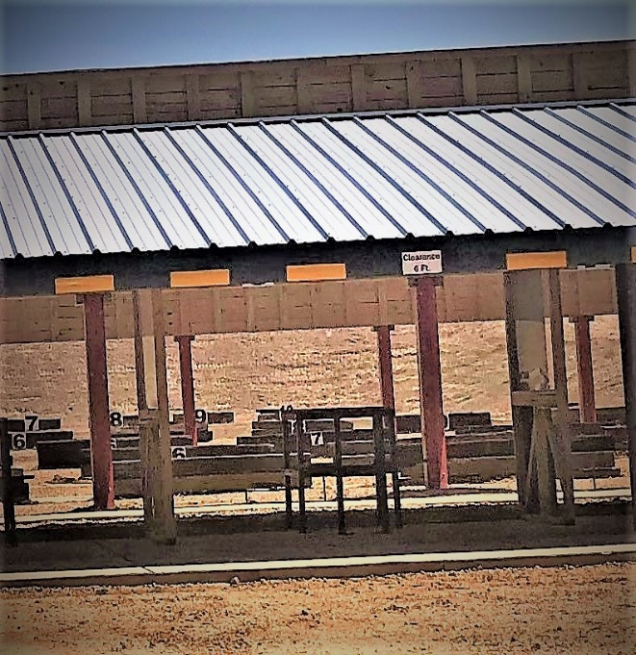

_________FEES ________

Rifle/Pistol Range fee is $7.00 per 1 hour session and includes 2 targets.
Additional targets are $2.00

Fees are $6 per round of trap or skeet, ages 18 and up; $5 per round <18; $4 per round with proof of membership in AYSSP. All rounds consist of 25 shots.

________RULES ________

*NO LOADED FIREARMS OR CONCEALED WEAPONS ALLOWED. Firearms are considered loaded if shells or cartridges are in the chamber, magazine, or cylinder.

*No firearms may be handled on the firing line while the range is clear.

*No tracer or incendiary ammunition of any kind is allowed.

*No firearms allowed in the range office without prior approval of range officer.

*Shooter MUST REGISTER before proceeding to the firing line.

*Shooters are responsible for the conduct of their guests.

*Any person causing a disturbance or problem will be asked to leave the grounds.

*Non-shooting patrons MUST remain behind the pad at both ranges.

*Minimum age unaccompanied is 16 for rifle or shotgun, 21 for pistol. Minimum age for rifle, pistol, skeet, or trap is 6.

*Shooters under the age of 16 MUST remain with adult while on the firing line.

*Rapid fire (more than 1 shot per second) is PROHIBITED.

*No alcoholic beverages or illegal substances(drugs) allowed on range property; persons believed to be under the influence of any intoxicants will be barred from the property.

*No smoking allowed on any of the ranges.

*Guests are LIABLE for any damage they cause to City property.

*Return all equipment to range office before leaving.

*During normal hours shooters may only retrieve their own brass. Discarded brass allowed on first come, first serve basis.

*The City of Warren is not liable for any personal injury, death, or damage to personal property while on City controlled ranges or property.

RIFLE/PISTOL RANGE RULES

*No more than 2 shooters are allowed at each bench.

*Firearms are to remain unloaded until the muzzle is pointed down range in the ready-to-fire position.

*When the range officer clears the range, all rifles must be unloaded with the actions opened. Pistols must be placed on the firing table and unloaded with slides locked open, magazines out, and cylinders open.

*DO NOT STEP FORWARD ON THE FIRING LINE until range officer has given permission.

*No firearm may be handled while the range is clear.

*No holstered handguns or quick draw allowed.

*No human silhouette, zombie, or any human form targets allowed.

